**ATAR HUMAN BIOLOGY**

**Unit 2**

Task 8: DNA, Cell & Human Reproductive Systems

**Name:**  **Weighting 5%**

**Date:**  **Mark:**

1. There are THREE sections in this test, Multiple Choice, Short Answer and Extended Answer.
2. This is a closed book assessment (no notes are allowed)
3. The time allowed to complete the test is 60 minutes
4. Write your answers to the Multiple Choice section on the **separate** answer sheet provided.
5. Write your answers to the Short Answer section in space provided.
6. Write your answers to the Extended Answer section in space provided.

|  |  |  |
| --- | --- | --- |
|  | **Marks Allocation** | **Your Total** |
| **Multiple Choice** | 10 |  |
| **Short Answer** | 45 |  |
| **Extended Answer** | 5 |  |
| **TOTAL** | 60 |  |

**Multi-choice Questions (10 marks)**

1. The DNA of a particular species of possum was analysed and it was found that 23% of its bases were guanine. What percentage of its bases would be adenine?

a) 23%

b.) 46%

c) 27%

d) 54%

1. Which of the following statements regarding DNA replication is true?
2. DNA replication does not require enzyme activity.
3. The ribosomes carry out DNA replication.
4. The process of DNA replication occurs in the nucleus.
5. DNA replication is a major process by which genes are rearranged along a chromosome.

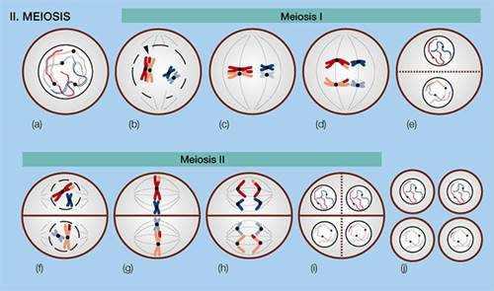

1. The two cells produced at (e), in the diagram above, are referred to as:
2. identical daughter cells.
3. haploid cells.
4. diploid cells.
5. daughter cells.
6. In meiosis, the chromosome number is halved in order to:

a) ensure the DNA is copied completely.

b) maintain all the DNA in the daughter cells.

c) ensure that errors in crossing-over can be corrected at fertilisation.

d) maintain the correct chromosome number in offspring.

1. The greatest chance for an ovum to be fertilised, is having sexual intercourse:
2. at the beginning of the menstrual flow.
3. two weeks after menstruation starts.
4. at the end of the menstrual flow.
5. at the end of the menstrual cycle.
6. Which of the following is NOT correct regarding spermatogenesis?
7. It begins before birth then ceases until after puberty.
8. It occurs continually after puberty.
9. The process takes about 72 days.
10. One spermatogonium results in four viable spermatozoa.

**Use the diagram below to answer Questions 7 & 8 .**

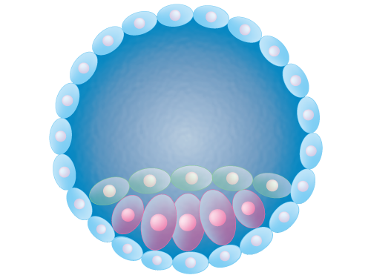

X

1. Which germinal stage of human embryogenesis does the diagram above represent?
2. Implantation
3. Fertilisation
4. Cleavage
5. Blastulation
6. During this stage, which structure releases hormones that maintain the endometrium ready for implantation?
7. Placenta
8. Corpus luteum
9. Ovary
10. Zygote
11. The process by which sperm are placed in the vagina naturally is called:
12. insemination.
13. ejaculation.
14. intercourse.
15. erection.
16. Which of the following substances would be in higher concentration in the umbilical arteries than in the umbilical vein?
17. Glucose.
18. Amino acids.
19. Vitamins.
20. Carbon dioxide.

**Short Answer Section (45 marks)**

1. In the space below:
2. Draw a diagram of a section of DNA showing the major components. (1 mark)
3. Label the main components that make up the DNA structure. (2 marks)
4. Circle one nucleotide. (1 mark)
5. Use the table below to complete the summary of mitosis. Name the stages described or outline the key events occurring at each stage named. NOTE: Stages are NOT listed IN ORDER. (4 marks)

|  |  |
| --- | --- |
| **Stage** | **Events** |
|  | Nuclear membranes and nucleoli form; chromosomes uncoil and disappear |
| Anaphase |  |
| Metaphase |  |
|  |  |

1. Use the table below to show **two differences** and **one similarity** between the processes of mitosis and meiosis. (3 marks)

|  |  |  |
| --- | --- | --- |
|  | **Mitosis** | **Meiosis** |
|  |  |  |
|  |  |  |
|  |  |  |

1. Label the summary of protein synthesis diagrammed below. (3 marks)

The process that happens here is _________________

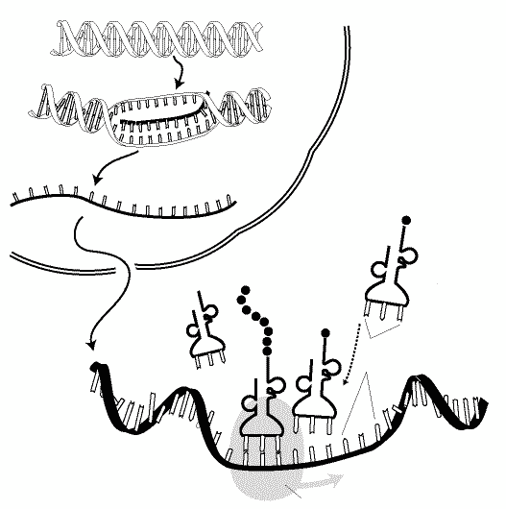

The process that happens here is _________________

1. Once the RNA polymerase has attached to the DNA, explain the sequence of events that happen in the nucleus as part of protein synthesis. Include all relevant names. (4 marks)

________________________________________________________________________________________________________________________________________________________________________________________________________________________________________________________________________________________________________________________________________________________________________________________________________________________________________________________________________________________________________________________________________________________________________________________________________________________________________________________________________________________________________________________________________________________________________________________

Use the following diagram of the male reproductive system to answer question six .

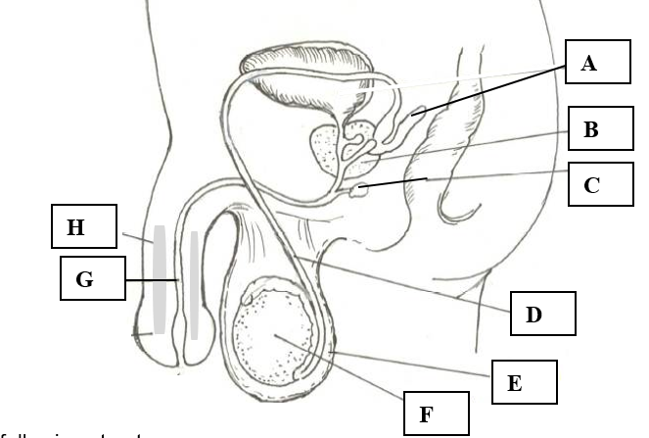

1. a) Label the following structures: (2 marks)

A: _______________________________________

C: _______________________________________

1. State the function of the following structures: (2 marks)

E : ____________________________________________________________________________

____________________________________________________________________________

G: ____________________________________________________________________________

____________________________________________________________________________

1. If a male developed prostate cancer and had to have his prostrate removed would he still be able to have children with his partner by natural means? Explain your answer. (3 marks)

________________________________________________________________________________________________________________________________________________________________________________________________________________________________________________________________________________________________________________________________________________________________________________________________________________________________________________________________________________________________________________________________________________________________________________________________________

1. a) State two important differences between the formation or characteristics of the spermatozoa and

the ova. (4 marks)

|  |  |  |
| --- | --- | --- |
| **Difference** | **Spermatozoa** | **Ova** |
| One |  |  |
| Two |  |  |

b) Choose one of the differences described in part f) (i) and explain how the process of reproduction would be affected if that difference did not exist. (2 marks)

________________________________________________________________________________________________________________________________________________________________________________________________________________________________________________________________________________________________________________________________

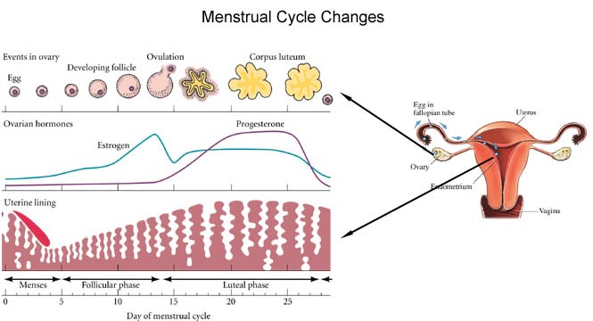Use the diagram below to answer the following questions.

1. What hormones are represented by the lines on the graph and explain how you came to your conclusion. (3 marks)

__________________________________________________________________________________________________________________________________________________________________________________________________________________________________________________________________________________________________________________________________________________________________________________________________________________________________________________________________________________________________________________

1. Many features of both reproductive systems depend on the endocrine glands for their regulation. The endocrine glands produce many hormones each has a specific target organ and effect.

Complete the following table identifying the hormones specific target organ(s) and its effect(s) in both male and females. (4 marks)

|  |  |  |
| --- | --- | --- |
| **Hormone** | **Target organ(s)** | **Effect(s) of hormone** |
| LH |  |  |
| FSH |  |  |

1. As the blastocyst develops into the embryo, there are three primary germ layers that develop first within the blastocyst, give two examples of structures that will be formed by the stem cells found in each of the primary germ layers. (3 marks)

Endoderm __________________________________________________________

Mesoderm __________________________________________________________

Ectoderm ___________________________________________________________

1. Once the blastocyst implants the placenta starts to form and takes about 3 months till it is fully functional. Discuss why an embryo/foetus would need such an organ as the placenta. (4 marks)

___________________________________________________________________________________

______________________________________________________________________________________________________________________________________________________________________________________________________________________________________________________________________________________________________________________________________________________________________________________________________________________________________________________________________________________________________________________________________________________________________________________________________________________________________________________________________________________________________________________________________________________________________________________________________________________________________________________________

**Extended response (5 marks)**

Explain the stages that occur, after puberty, during Oogenesis. Include relevant names and places where events occur.